pasted-image.tiff

# CIFAR-10 Image Classification - Comparative Analysis

[**Advanced Systems Project**](javascript:void(0))

**NAME: PRIYANKA MULA**

**SID: 700741307**

**Table of Contents**

1. Introduction

1.1 Background

1.2 Objective

1.3 Overview of CIFAR-10

1.4 Why Transfer Learning?

1.5 The Four Models for Comparative Analysis

1.6 Structure of the Report

2. Literature Review

2.1 Overview of Deep Learning

2.2 Transfer Learning

2.2.1 Introduction

2.2.2 Historical Context and Evolution

2.2.3 Detailed Mechanism of Operation

2.2.4 Significance and Benefits of Transfer Learning

2.2.5 Potential Challenges of Transfer Learning

2.2.6 Common Use Cases

2.3 ResNet50 Architecture

2.3.1 Overview and History

2.3.2 Key Features and Advantages

3. Data Exploration

3.1 Dataset Overview

3.2 Data Visualization

4. Modeling

4.1 Preprocessing

4.1.1 Introduction

4.1.2 Directory Structure and File Initialization

4.1.3 Data Deserialization and Extraction

4.1.4 Image and Label Segregation and Reshaping

4.1.5 Data Visualization

4.1.6 Data Transformation for Model Compatibility

4.2 Design and Architecture

4.2.1 Model 1

4.2.2 Model 2

4.2.3 Model 3

4.2.4 Model 4

4.3 Model Compilation

4.3.1 Loss Function

4.3.2 Optimizer

4.3.3 Metrics

4.4 Model Training

4.4.1 Setting Callbacks

4.4.2 Training Procedure and Visualization

4.5 Model Evaluation

4.5.1 Training and Validation Curves

4.5.2 Testing the Model

5. Analysis and Results

5.1 Model Accuracy and Loss

5.2 Error Analysis

5.3 Comparing with Other Methods/Models

5.4 Conclusion

6. Deployment

7. Conclusion

8. References

**1. Introduction**

**1.1 Background**

Machine learning, a significant subset of artificial intelligence, has undergone transformative advancements over the past few decades. Among these, deep learning methodologies, particularly Convolutional Neural Networks (CNNs), have proven to be revolutionary. These networks, designed specifically for intricate image data analysis, have the capacity to detect and interpret subtle patterns and features that elude the human eye. Their impact is felt profoundly in the domain of image classification, reshaping how systems 'see' and comprehend visual data. CNNs have extended their reach far beyond mere academic research, showcasing their prowess in practical, real-world applications. In the automotive world, they play an instrumental role in the functionality of autonomous vehicles, ensuring they interpret and respond appropriately to their environment.

However, the effectiveness of CNNs comes with certain demands. Primarily, they need an extensive collection of labeled images for training and refining their capabilities. This vast pool of data serves as the bedrock of their understanding. Complementing this requirement is the need for robust computational infrastructure to handle the complex operations intrinsic to deep learning a challenge that often surpasses the resources of individual researchers or smaller entities. Recognizing these constraints, the machine-learning community sought ways to democratize the advantages of CNNs. This endeavor gave birth to techniques like ‘transfer learning’.Instead of building models from scratch, researchers and developers can now adapt these pre-trained models to specific tasks, significantly reducing the need for vast datasets and high computational power. Thus, transfer learning has emerged as a beacon, making the marvels of deep learning more accessible to a wider spectrum of users.

**1.2 Objective**

In the ever-evolving landscape of artificial intelligence and machine learning, there arises a continuous need to evaluate and compare the tools and techniques that this field offers. Such comparisons not only facilitate informed decision-making but also pave the way for further innovation. It is in this spirit of exploration and understanding that the present report has been conceived. At the heart of this endeavor lies a singular, overarching ambition: to dive deep into the intricacies of various neural network architectures, encompassing both those crafted from scratch as well as those that come pre-trained, boasting prior knowledge from other tasks. Our dataset of choice for this investigative journey is the CIFAR-10, a widely recognized and employed collection of images spanning ten distinct categories. This dataset has been a benchmark in the image classification domain, offering a balanced mix of complexity and manageability, making it an ideal candidate for our study.

By immersing ourselves in this comparative study, we aim to unravel several layers of understanding. Firstly, we wish to dissect the individual performances of these neural network models, assessing how they fare when tasked with classifying the images from the CIFAR-10 dataset. But our quest doesn't stop at mere performance metrics. We intend to delve deeper, juxtaposing the accuracy of these models against the computational resources they consume. Such a holistic examination will empower us to ascertain which among the various architectures stands out, not just in terms of its ability to classify images correctly but also in its efficiency and adaptability in different scenarios.

By the culmination of this rigorous analysis, our objective is clear and well-defined. We seek to pinpoint that one neural network model which strikes an optimal balance, providing high accuracy without compromising on computational efficiency. Moreover, we also hope to shed light on the circumstances and conditions under which these models thrive, thereby offering insights that could guide future endeavors in the domain of image classification.

**1.3 Overview of CIFAR-10**

In the expansive universe of machine learning and artificial intelligence, there exist several landmarks that researchers and enthusiasts alike consider as pivotal stepping stones. Among these, the CIFAR-10 dataset emerges as one such significant cornerstone. Renowned and held in high regard within the machine learning community, CIFAR-10 stands as a testament to the ever-evolving challenges and opportunities in the realm of image classification.

CIFAR-10, which can be viewed as a curated collection of visual data, boasts a whopping 60,000 images. These images are meticulously organized and equally apportioned across 10 distinctive classes, capturing the essence of everyday objects and creatures. From the mechanical grace of airplanes and automobiles to the natural allure of birds and cats, this dataset spans a wide spectrum, ensuring diversity and complexity.

However, what makes CIFAR-10 particularly unique is the uniformity of its image dimensions. Every single image housed within this dataset adheres to a size of 32x32 pixels. But do not let this seemingly modest resolution deceive you. Despite their compactness, these images encapsulate rich visual information, courtesy of their three color channels – Red, Green, and Blue. These channels breathe life into the images, painting them in a myriad of hues and shades.

Given this blend of diversity and consistency, CIFAR-10 becomes a playground for machine learning models. It presents a controlled yet challenging environment, where the models are tasked with discerning and differentiating between the various classes. This dual nature of CIFAR-10, where it is both accessible and demanding, makes it an ideal candidate for researchers and practitioners who are keen on testing, tweaking, and perfecting their model architectures, ensuring they are well-equipped to tackle real-world image classification challenges.

**1.4 Why Transfer Learning?**

Transfer learning is an interesting and valuable approach in the vast realm of machine learning. At its core, transfer learning can be compared to applying knowledge we've gained from one area to assist in a different, but somewhat related area. Imagine if someone is good at one sport, say basketball, and then they decide to try their hand at another sport, like netball. They wouldn't be starting from zero; they would bring over some skills from basketball that would help them in netball. Similarly, in machine learning, instead of building a model from the ground up, transfer learning enables us to utilize a model that was originally trained for one specific task to aid in a slightly different task.

Consider having a model that has been trained to recognize a vast array of general objects. This model, because of its wide training, has a broad understanding of many visual patterns. If we want to specialize this model to identify, let's say, just types of birds, we don't have to train it from scratch. We can just make some adjustments to the already trained model, refining its knowledge based on a smaller set of bird images. This is especially beneficial when we don't possess a large collection of data for our specific task. It might be hard to collect thousands of pictures of rare birds, for example.

By leveraging transfer learning, not only do we save invaluable time but also significantly reduce the computer power needed. It's an efficient method that sidesteps the arduous process of training a deep model entirely from scratch. For this reason, many professionals and enthusiasts in the machine learning community view transfer learning as an indispensable tool. It presents an opportunity to achieve commendable results without the necessity of vast datasets or an extended training period. It's akin to being handed a partially completed puzzle and then only needing to fit in the final pieces to see the whole picture.

**1.5 The Four Models for Comparative Analysis**

In our in-depth study, we have made a deliberate choice to examine four distinct and unique models, each with its set of characteristics and advantages. We hope to provide a clearer understanding of their individual capabilities when applied to the CIFAR-10 dataset. Here's a brief overview of each:

**- Model 1:** The first model in our line-up is a custom-built Convolutional Neural Network. It is specifically designed with the CIFAR-10 dataset in mind. The architecture has been structured to cater to the specific nuances and diversity of images within this dataset, ensuring that it can capture the essential features effectively.

**- Model 2:** Our second model doesn't start from scratch. Instead, it harnesses the proven capabilities of the ResNet50 architecture, a renowned and powerful neural network structure. Through the technique of transfer learning, this model adapts the broad knowledge of ResNet50 to specialize it for the CIFAR-10 dataset. This strategy allows us to benefit from the extensive training and versatility of ResNet50 while tuning it for our specific challenge.

**- Model 3:** Diving deeper into custom architectures, the third model introduces some unique elements. It doesn't just use any regular activation function; it employs the Exponential Linear Unit (ELU) activations. Moreover, the structure incorporates specially crafted convolutional blocks, fine-tuned to extract intricate patterns from the images more effectively.

**- Model 4:** Bearing similarities to Model 3, this model is also custom-built, but there's a twist. Instead of ELU activations, it opts for the more traditional Rectified Linear Unit (ReLU) activations. This choice allows us to draw direct comparisons between the two activation functions and their impact on model performance.

By carefully selecting and evaluating these four diverse models, our intention is to offer readers a wide-angle perspective. We aim to highlight the strengths and weaknesses of each approach, how they contrast with each other, and which scenarios might be most suitable for each. This comparative lens, we believe, will furnish insights that are both detailed and broad, catering to a range of readers from beginners to experts.

**1.6 Structure of the Report**

**Introduction**

In this section, an overview of the report is presented. It begins with a brief background, followed by a statement of the objectives. The introduction introduces the CIFAR-10 dataset, elucidates the choice of using transfer learning, and outlines the four models under analysis. Finally, the section concludes by presenting an outline of the report's structure.

**Literature Review**

The literature review section serves to contextualize the study. It commences with an overview of deep learning as a foundational concept. Subsequently, it delves into transfer learning, covering its definition, significance, and common applications. The section also expounds upon the ResNet50 architecture, tracing its historical development and elucidating its key features and advantages.

**Data Exploration**

Within this section, the CIFAR-10 dataset is explored in detail. It commences with an overview of the dataset, followed by an exposition of data visualization techniques. This exploratory step aims to familiarize readers with the dataset before progressing to the modeling phase.

**Modeling**

The Modeling section constitutes the core of the report, detailing the process of constructing and training the models. The process is initiated with preprocessing procedures, including data preparation and transformation. Subsections are dedicated to various aspects of preprocessing, including directory structure, data extraction, reshaping, visualization, and data transformation. The section proceeds to elaborate on transfer learning, with separate subsections dedicated to each of the four models employed. The compilation of models, involving the specification of loss functions, optimizers, and metrics, is also outlined. Additionally, the section includes separate subsections delineating the processes of model training and evaluation.

**Results and Discussion**

In this section, the outcomes of the models are presented and critically discussed. It commences with an analysis of model accuracy and loss. Subsequently, a comprehensive error analysis is undertaken, encompassing the presentation of a confusion matrix and an evaluation of class-wise accuracy. The section culminates in a comparative analysis with other methods or models, offering insights into the effectiveness of the approach adopted.

**Conclusion and Future Work**

The concluding section provides a synthesis of the findings, restating the research objectives, and proposing potential avenues for improvement. It also suggests directions for future research, informed by the insights derived from the study.

**References**

The References section functions as a comprehensive list of all sources and references utilized throughout the report. It adheres to a specific citation style in accordance with institutional guidelines or academic conventions.

**2. Literature Review**

**Overview of Deep Learning**

**Beginning Stages and Introduction**

Deep learning finds its place within a larger domain known as machine learning. Machine learning itself is a part of an even broader field, artificial intelligence. Artificial intelligence encompasses all techniques that equip machines with capabilities similar to human intelligence. Within artificial intelligence, machine learning specifically deals with enabling machines to learn and make decisions from data without explicit instructions. Delving deeper within machine learning, there's a unique approach that learns from a large volume of data through layered structures. This approach is the subject of focus: deep learning.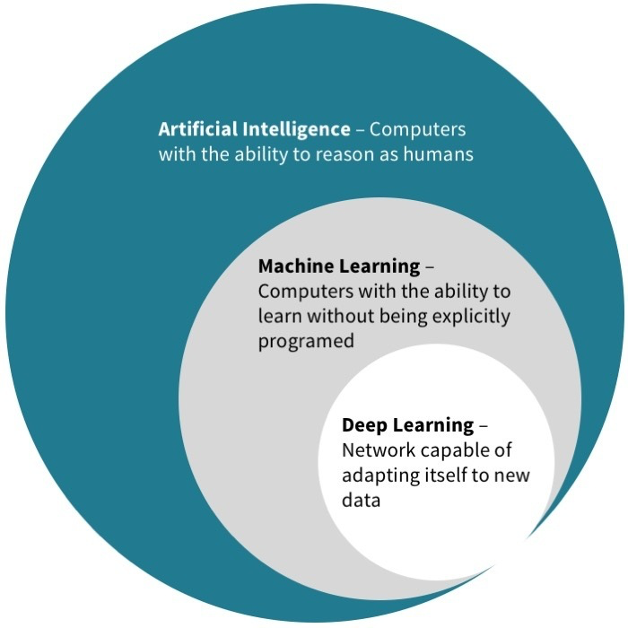

Fig 1. Artificial Intelligence Hierarchy - [Source](https://miro.medium.com/v2/resize:fit:700/1*temxwiP_H9lQbVVO5RCgPw.png)

**Historical Context and Evolution**

The concept of deep learning has deep historical roots. Many years ago, when technological advancements were in the initial stages, certain visionaries and researchers took inspiration from the human brain. The human brain, with its complex web of neurons, processes information in a rich and dynamic manner. This led to a pivotal question: "Could there be a machine mechanism mimicking this intricate human brain structure?" Such ponderings paved the way for the birth of artificial neural networks, the foundational building blocks of deep learning.

Artificial neural networks sought to imitate the way the human brain operates. These networks are comprised of nodes or "neurons", structured in layers. Data gets processed as it moves from one layer to another, with each layer learning a different aspect of the data.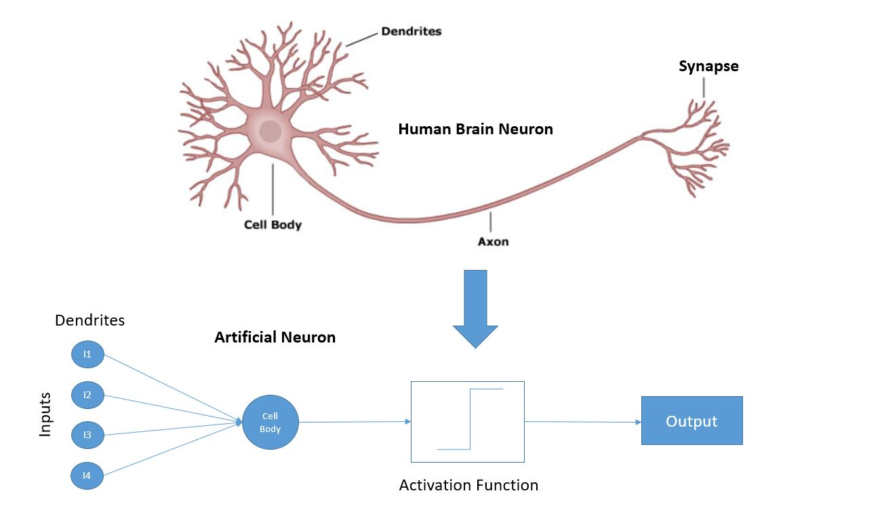

Fig 2. Biological Neuron vs. Artificial Neuron - [Source](https://3.bp.blogspot.com/-aJO1rNOyXSA/Whb4igsgG4I/AAAAAAAACdk/iI4sGpUX72UQfOS7dmD38U8kdgGz-km_wCLcBGAs/s1600/Neuron-Machine+learning-Shivlu+Jain.JPG)

**Growth and Significance in Modern Times**

With the advent of better computational power and the availability of large datasets, deep learning gained immense traction in recent decades. The idea that machines could be trained to recognize patterns in data, especially when data is vast and complex, became more feasible and effective. This kind of pattern recognition has enabled several technological marvels.

Deep learning techniques have now transformed various sectors. In the domain of image processing, machines can now recognize objects and even faces. In the world of language, translation between different languages and understanding human speech have become more accurate. These advances owe a lot to the layered, deep structures of learning that deep learning brings to the table.

**Conclusion and Looking Ahead**

In essence, deep learning represents a significant leap in the world of artificial intelligence. As a subset of machine learning, it taps into the potential of vast datasets and processes information in a manner inspired by the human brain. With each passing year, as technology advances and data becomes more available, deep learning will continue to play an even more pivotal role in shaping the future of technological innovations.

**2.2 Transfer Learning**

**2.2.1 Introduction:**

Transfer learning stands out as a notable strategy in the realm of machine learning, particularly when there's a need to expedite the learning process or when data is scarce. It stems from a practical observation: if a model has been adequately trained on a comprehensive dataset for a particular task, it already encapsulates a substantial amount of information about the domain. Such a model, having been exposed to various intricacies and nuances of the data, possesses a generic understanding, which can be likened to a broad overview of the visual world. This makes it an invaluable asset, especially when it can be repurposed or fine-tuned to address a related task.

Building on this foundation, transfer learning ensures that we don't reinvent the wheel. Instead of starting the arduous journey of training a model from scratch, which often demands vast amounts of data and computational resources, transfer learning allows us to utilize pre-trained models as a starting point. By doing so, we can capitalize on the patterns, features, and knowledge these models have already acquired. The subsequent fine-tuning or adaptation process then focuses on the specific nuances of the new task at hand. This approach not only conserves resources but often leads to superior performance, as the model benefits from a rich, pre-established knowledge base before being tailored to the specific task.

**2.2.2 Historical Context and Evolution:**

Transfer learning's origin is deeply rooted in the practical challenges faced by early machine learning practitioners. In the initial days of the field, each new problem was approached as a separate entity, necessitating the collection and annotation of extensive datasets for every single task. Training models for each specific task were not only resource-intensive but also time-consuming. The era was characterized by models with limited capabilities and industry still coming to grips with the optimal practices for model training and evaluation.

However, as the domain of machine learning expanded and more researchers delved into its depths, certain universal truths began to emerge. One such realization was that many learning tasks shared commonalities. The patterns and structures learned in one context often had relevance and applicability in another, albeit slightly different, context. This observation, coupled with the burgeoning availability of large-scale pre-trained models and datasets, paved the way for the conceptualization of transfer learning.

Instead of seeing each learning task as an isolated challenge, the community began to view them as interconnected nodes in a vast web of knowledge. The shift in perspective was transformative. By leveraging pre-existing knowledge from one domain and applying it to another, models could be trained more efficiently, often with better accuracy, and without the need for exhaustive data collection efforts. This evolution marked a significant turning point in the field, with transfer learning emerging as a cornerstone technique in modern machine learning applications.

**2.2.3 Detailed Mechanism of Operation:**

Transfer learning is a cornerstone in machine learning, offering a sophisticated yet straightforward strategy to optimize the training process. At its core, this approach facilitates the reuse of established knowledge, ensuring a more efficient learning curve for new tasks. Understanding the operational mechanics of transfer learning involves breaking down its main components and interactions.

To begin with, transfer learning operates within two foundational realms termed as 'source domain' and 'target domain'. The source domain can be visualized as a reservoir of pre-existing knowledge. It is where a model has previously interacted with vast amounts of data, undergoing rigorous training sessions and accumulating vital patterns and insights. This domain provides the base, offering a vast array of learned behaviors and understandings. On the other end is the 'target domain'. Here, the objective is to apply the garnered knowledge from the source domain to new challenges or tasks. While they may be distinct, both these domains are bound by data and the tasks they aim to accomplish.

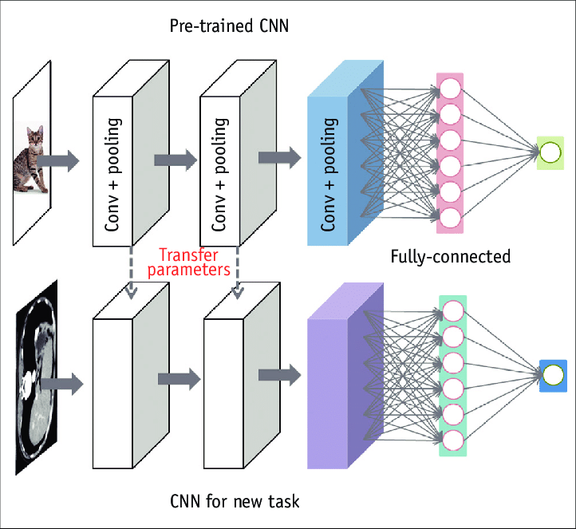

Fig 3. Transfer Learning Illustration - [Source](https://www.researchgate.net/publication/338540456/figure/fig1/AS:850909840015360@1579884123355/Transfer-learning-Transfer-learning-is-process-of-taking-pretrained-model-usually.png)

Shifting the focus to the heart of the process, deep learning models, especially those nurtured on large datasets, inherently evolve to recognize a spectrum of features. This spectrum spans from very basic or low-level features, such as simple patterns and contrasts, to intricate or high-level features that might relate to more complex patterns. As one transition towards transfer learning, it's this inherent understanding, embodied in the weights and patterns of the pre-trained model, that is leveraged. Such a model doesn't begin its journey in the target domain without any prior knowledge. Instead, it starts with an initialization grounded in its past experiences, ready to adapt and refine itself based on the new data it encounters.

Further diving into the nuances, one encounters two pivotal strategies within transfer learning: 'Fine-tuning' and 'Feature Extraction'. When there's an abundance of data available in the target domain, fine-tuning becomes a feasible strategy. Here, the entirety of the pre-trained model, from its initial layers to its final ones, is open to adjustments. Every layer's weights can be modified to resonate more harmoniously with the new task, ensuring a comprehensive adaptation. Contrastingly, in situations characterized by limited data, a more cautious approach, termed feature extraction, is adopted. In this strategy, the initial layers of the model, which are generally believed to hold more universal or generic understandings, are kept constant or 'frozen'. The focus shifts to the latter layers, adjusting and training them to be more in sync with the specific requirements of the new task. This ensures that the model remains grounded in its foundational knowledge while tailoring its higher-level understanding to the nuances of the target domain.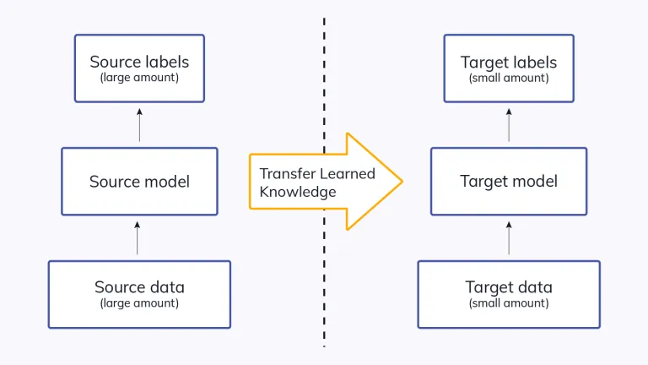

Fig 4. Transfer Learning Depiction - [Source](https://i0.wp.com/neptune.ai/wp-content/uploads/2022/10/Transfer-learning-idea.jpg?resize=768,432&ssl=1)

In essence, transfer learning emerges as a symphony of strategies and understandings, seamlessly integrating past learnings to forge a path for future successes. By embracing the wisdom of the old while being receptive to the new, it stands as a testament to the evolving nature of machine learning.

**2.2.4 Significance and Benefits of Transfer Learning:**

1. **Efficiency in Training:**

Transfer learning stands out as a beacon of efficiency in the vast sea of machine learning methodologies. By leveraging knowledge from previously trained models, transfer learning alleviates the need to train a model entirely from the ground up. This approach ensures that the model does not spend redundant time and computational resources trying to understand patterns that have already been deciphered in a different context. Thus, the overall duration and effort invested in training the model for the new task are considerably diminished, allowing for a faster deployment of solutions.

**2. Data Economization:**

In the modern era, while data is abundant, securing labeled data for specific tasks remains a challenge. Labeling can be time-consuming, expensive, and requires domain-specific expertise. Transfer learning emerges as a solution to this bottleneck. By utilizing the knowledge gained from pre-trained models, there's a reduced dependency on vast quantities of labeled data for the new task at hand. Instead of starting afresh, the model can capitalize on the patterns and insights from the source domain, making the most of the limited labeled data available for the target task.

**3. Performance Augmentation:**

The pursuit of excellence in machine learning often revolves around enhancing model performance. Transfer learning plays a pivotal role in this pursuit. When a model taps into pre-existing knowledge, it often achieves a higher level of accuracy and efficiency, especially when compared to models that are trained from scratch using limited data. The foundational understanding from the source task acts as a robust springboard, enabling the model to reach optimal performance levels faster and more reliably. This inherent advantage of transfer learning ensures that it remains a preferred choice for many machine learning tasks.

**2.2.5 Potential Challenges of Transfer Learning:**

**1. Dependence on Task Similarity:**

One of the fundamental pillars of transfer learning is the assumption that the knowledge derived from the source task has relevance and applicability to the target task. However, this is not always the case. If the tasks are inherently different or operate in entirely separate domains, using insights from one to inform the other can be misleading. It's crucial to ensure that there's an underlying similarity or commonality between the tasks for transfer learning to be genuinely effective.

**2. Risk of Subpar Performance:**

Building on the first point, if there's a misalignment between the source and target tasks, not only does the advantage of transfer learning diminish, but there's also a risk of the model performing poorly on the target task. This is because it might be operating on patterns and insights that don't necessarily apply to the new data or context. Instead of aiding the learning process, the transferred knowledge might introduce noise or confusion, leading to results that are not up to the desired standard.

**3. Complexity of Determining Compatibility:**

While it might seem straightforward to judge the compatibility of tasks, in practice, this can be a complex endeavor. Determining the extent to which two tasks share common features or patterns requires a deep understanding of both domains. Moreover, even if there is some overlap, figuring out the right amount of knowledge to transfer, which layers of a deep learning model to freeze or fine-tune, and other such considerations can be intricate. Making incorrect judgments in these areas can negate the benefits of transfer learning.

**2.2.6 Common Use Cases:**

**Expounding on the Varied Use Cases of Transfer Learning**

The concept of transfer learning, as previously described, resonates profoundly with its inherent adaptability and flexibility. This has paved the way for its incorporation into a wide array of domains and applications, each having its unique challenges and requirements. Delving into the multifaceted use cases of transfer learning, the versatility of this technique becomes evident.

**Image Classification and its Subtleties**

In the realm of image classification, vast repositories of images, such as the renowned ImageNet database, provide an expansive playground for training intricate models. These models, having been exposed to a multitude of diverse images, attain proficiency in discerning nuanced patterns and features. When confronted with a narrower image classification task, perhaps one with a limited set of images, the logical step is not to start from a blank slate. Instead, transfer learning comes to the fore. By leveraging a model previously trained on the extensive ImageNet database, and subsequently fine-tuning it with the specific set of images in question, practitioners can harness the model's pre-existing knowledge. This allows for a more rapid and potentially more accurate classification process, even when the available images for the specific task are scarce.

**Natural Language Processing: A World of Textual Nuances**

Moving on to the domain of Natural Language Processing (NLP), the vastness and intricacy of human language present unique challenges. There exist extensive text corpora, each rich with linguistic intricacies. Models trained on such large-scale text collections gather a comprehensive understanding of language structures, semantics, and contexts. Now, when faced with a more specialized task, say sentiment analysis or translation, where the dataset might not be as expansive, transfer learning shines yet again. Instead of constructing a model from scratch, NLP practitioners can repurpose models that have undergone rigorous training on the larger text corpora. By doing so, the models carry forward their understanding, making it easier and more efficient to tackle specific tasks, even if the available textual data for these tasks is limited.

**Medical Imaging: A Crucial and Sensitive Application**

Lastly, venturing into the critical domain of medical imaging, the stakes are significantly heightened. Diagnoses based on medical images can have profound implications, and accuracy is paramount. However, a challenge that often arises is the lack of abundant labeled medical images, primarily due to patient privacy concerns and the inherent rarity of certain medical conditions. Under these constraints, training a model from ground zero can be daunting. However, transfer learning offers a beacon of hope. By taking models that have been trained on generic, non-medical images and adjusting them to the specific nuances of medical imaging, practitioners can achieve a head start. This approach, by leveraging pre-existing knowledge, can assist in detecting abnormalities or conditions in medical images with greater precision and confidence, even when the volume of available medical images is not vast.

In light of the above, it becomes evident that transfer learning, with its adaptability, has carved a niche for itself across diverse domains. Whether it's deciphering images, understanding the complexities of language, or aiding in critical medical diagnoses, transfer learning consistently proves its mettle by allowing for knowledge reuse in the most practical of ways.

**2.3 ResNet50 Architecture**

**2.3.1 Overview and History**

ResNet50, a term that has become synonymous with advanced deep learning, is intricately tied to its parent architecture, the ResNet or Residual Network. This architectural innovation emanated from the minds at Microsoft Research and made its debut in the year 2015. When diving into the nomenclature, the specific annotation "50" in ResNet50 provides a hint about its structure. Specifically, this number indicates that the architecture encompasses a total of 50 layers, which is quite deep compared to some of its contemporaries. Each layer, in essence, plays a crucial role in extracting patterns and features from the input data.

Looking back at the trajectory of neural network development, the community was pushing the boundaries, making networks deeper to improve accuracy and model complexity. However, this journey wasn't without its challenges. As these networks grew in depth, an unexpected phenomenon was observed. Instead of continually improving, these deeper networks began to exhibit diminishing benefits. Even more puzzling was that there were instances where their performance started to wane, showing regression rather than progression.

This puzzling downturn in performance begged for a solution, and this was the context in which the ResNet architecture emerged as a beacon of innovation. The genius behind ResNet was its ability to mitigate the challenges of training ultra-deep networks. The cornerstone of this architecture was what came to be known as "skip connections" or, in more technical terms, "residual blocks.”

To elucidate further, as data or input flows through a deep network, it gets transformed multiple times. With each transformation, there's the potential for loss of information, and the network might struggle to retain the original features of the data. This is where the brilliance of "skip connections" comes into play. Instead of letting the data flow through every layer sequentially, these connections allow for a bypass. They let the data "skip" some layers and then add it back to the output of subsequent layers. This seemingly simple addition was groundbreaking. By doing this, the model could retain some of the original data throughout the network, making it easier for gradients to traverse during training. The end result? Deeper networks, like ResNet50, could now be trained more efficiently, overcoming the hurdles previously faced with deep network training.

In essence, the introduction of the ResNet architecture, and specifically the ResNet50 variant, marked a significant milestone in the journey of deep learning, proving that with innovation, even the most perplexing challenges can be overcome.

**2.3.2 Key Features and Advantages**

ResNet50, an integral member of the renowned ResNet architectural lineage, stands out for a plethora of reasons, each contributing to its widespread adoption and commendable performance in multiple applications. Here, an attempt is made to thoroughly discuss the characteristics that set ResNet50 apart and the advantages that emanate from these features:

**The Phenomenon of Skip Connections:** At the forefront of ResNet50's distinctive features are the 'Skip Connections.' As the name subtly hints, these connections enable data to take a shortcut and bypass certain layers during the training phase. This bypassing mechanism is not just a whimsical design choice; it has profound implications. By facilitating such skips, the network paves the way for learning identity functions, ensuring that crucial information is retained. Moreover, these skip connections play a pivotal role in circumventing a long-standing challenge in deep learning known as the vanishing gradient problem. This problem, where gradients tend to get smaller and almost negligible as they are propagated back through the network, can stall the training process. Skip connections effectively mitigate this issue.

**The Depth of the Architecture:** ResNet50 is not named whimsically; the '50' denotes its depth, signifying the 50 layers it comprises. This depth isn't merely about numbers; it grants the architecture the capability to discern and extract complex patterns and data hierarchies. Such depth is invaluable when the task at hand demands understanding intricate relationships within the data.

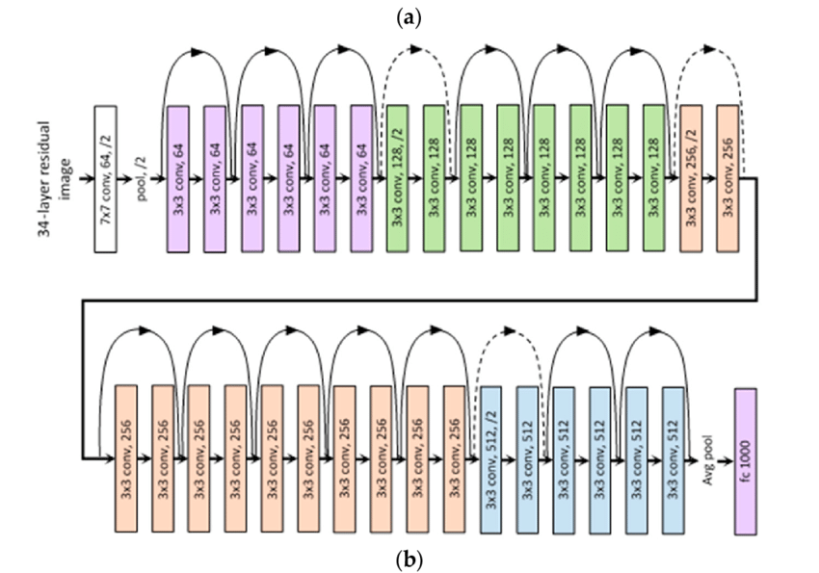

Fig 5. ResNet 50 Architecture - [Source](https://miro.medium.com/v2/resize:fit:850/1*C8jf92MeHZnxnbpMkz6jkQ.png)

**Training Efficiency Par Excellence:** Intuition might suggest that with increased depth comes increased complexity and, consequently, longer training times. However, ResNet50 turns this intuition on its head. Despite boasting 50 layers, the architecture exhibits commendable efficiency during the training phase. This efficiency stems from its ingenious design, particularly the residual blocks. These blocks ensure that as layers are added, the network doesn't plateau or degrade in performance but continues to harness the advantages of increased depth.

**A Testament to Versatility:** Beyond its structural features, what truly underscores the prowess of ResNet50 is its adaptability. This architecture hasn't limited itself to a niche; it has showcased its mettle across a spectrum of tasks. Whether it's the realm of image classification or the challenge of object detection, ResNet50 has delivered commendable results, underscoring its versatility and robust nature.

In summation, when the discussion veers towards deep learning architectures that blend depth with efficiency and versatility, ResNet50 inevitably finds mention. Its features and the resultant advantages make it not just a theoretical marvel but a practical tool that has been and continues to be, instrumental in advancing the frontiers of machine learning. It stands as a testament to what thoughtful design, coupled with innovation, can achieve in the ever-evolving domain of machine learning.

**3. Data Exploration**

**3.1 Dataset Overview**

The CIFAR-10 dataset, an esteemed resource in machine learning, primarily serves the realm of image classification. Its name, CIFAR, is an acronym derived from the Canadian Institute for Advanced Research, the prestigious institution responsible for its inception. The dataset's creation aimed to foster advancements and stimulate innovative practices in the expansive field of computer vision, which is essentially about enabling machines to interpret and understand visual data.

Contained within the CIFAR-10 dataset is an assortment of 60,000 meticulously curated color images. Each image is consistently sized, measuring precisely 32 pixels in width and 32 pixels in height. Such uniformity is essential to maintain consistency during computational processing. These images aren't just a random assortment; they are methodically categorized into ten distinct classifications, each representing common objects or entities. These classes encompass a range of familiar items, often encountered in daily life:

|  |  |
| --- | --- |
| 1. Airplane | 2. Automobile |
| 3. Bird | 4. Cat |
| 5. Deer | 6. Dog |
| 7. Frog | 8. Horse |
| 9. Ship | 10. Truck |

An important aspect to note is the balanced representation: every single class in the dataset comprises exactly 6,000 images. This ensures that when algorithms are trained using this dataset, they are exposed to an equal number of examples from each category.

Furthermore, the structure and organization of the dataset have been designed with meticulous attention to detail. Out of the aggregate of 60,000 images, a generous portion of 50,000 images is dedicated for training purposes. This provides an ample volume of data, ensuring that machine learning models have a comprehensive foundation to learn from. In contrast, the subsequent set of 10,000 images is set aside explicitly for testing. This segregation is pivotal, as it allows researchers, data scientists, and machine learning practitioners to rigorously evaluate and benchmark the performance of their models in a controlled and standardized setting.

Opting for such a balanced distribution in the dataset is instrumental in machine learning model training. It helps to ensure that models, during their training phase, do not inadvertently develop a skew or preference towards any specific class. As a result, when these trained models are later deployed in real-world applications, they exhibit a more generalized understanding of images, leading to enhanced reliability and robustness in their predictions. The CIFAR-10 dataset, with its careful curation and balanced structure, remains a testament to the importance of quality data in the realm of machine learning.

**3.2 Data Visualization**

Delving into data through visualization, particularly for image-centric datasets like CIFAR-10, paves the way to discern profound insights and gain a comprehensive grasp of the data's intrinsic nature. Each image within this dataset, meticulously sized at a 32x32 pixel resolution, encapsulates a plethora of details. This rich information is manifested in the vibrant color variations, intricate object silhouettes, and nuanced background elements present in each image. Such granular details are instrumental in steering the training trajectory of machine learning algorithms, ensuring they understand and interpret data with precision.



Fig 6. Sample Image of Deer class (32x32 pixels)

Capitalizing on the capabilities of contemporary visualization tools and techniques, it becomes feasible to curate a visual representation, akin to a tapestry, comprising images from every class present in the dataset. Such a comprehensive visual compilation offers observers a panoramic overview, illuminating the vast diversity and range that the CIFAR-10 dataset encompasses. Engaging with this visual exposition equips practitioners with an awareness of potential challenges that could manifest during the modeling phase. As an illustrative example, certain images within the dataset are characterized by their clarity and distinguishable features. In stark contrast, there exist other images that tread the line of ambiguity, introducing an added layer of complexity to the classification endeavor.

To further augment this visual exploration, graphical representations such as histograms and bar charts can be employed. These visual aids are instrumental in highlighting the distribution dynamics of the different classes within the dataset. Their visual presentation underscores the meticulous balancing act inherent in the dataset's design, ensuring no class is overrepresented or underrepresented. Moreover, the realm of visualization is expansive, allowing practitioners to go beyond mere distribution representations. For instance, showcasing images that were erroneously classified during model evaluation can offer invaluable insights. Highlighting these misclassifications can serve as a diagnostic tool, pointing researchers toward potential weaknesses or areas warranting refinement in the machine learning model.

In summation, the CIFAR-10 dataset, distinguished by its eclectic mix of images and equitably distributed classes, stands as a beacon for those keen on harnessing the prowess of machine learning models. When complemented with meticulous and strategic data visualization, it offers researchers a magnified view into the dataset's depths, ensuring the journey from data to model is informed, insightful, and ultimately successful.

**4. Modelling**

**4.1 Preprocessing**

**4.1.1 Introduction**

The CIFAR-10 dataset stands as one of the most prominent and widely recognized datasets in the machine learning and data science communities. This dataset comprises a rich assembly of 60,000 vibrant, colored images. Remarkably, each of these images is standardized to dimensions of 32x32 pixels, ensuring uniformity across the entire dataset. These images span across a total of 10 unique classes, providing a diverse range of visual data. Remarkably, each of these ten classes contains an equal representation, with a count of 6,000 images per class. This equitable distribution ensures that no single class is overrepresented or underrepresented, fostering balanced machine learning modeling.

Delving deeper into the data allocation, out of the total 60,000 images, a substantial chunk, precisely 50,000 images, have been specifically designated for training. This training set plays a pivotal role in building and refining machine learning models. On the other hand, the remaining 10,000 images are reserved exclusively for testing purposes. These test images are instrumental in evaluating and benchmarking the performance of trained models in scenarios mirroring real-world applications.

The task of data preprocessing stands as an indispensable foundation for any successful machine learning project. It is a comprehensive process that readies the dataset by refining, transforming, and optimizing its structure, ensuring it's primed for efficient and effective training. Without this vital step, even the most sophisticated models might falter or underperform due to potential inconsistencies or anomalies present in the raw data.

**4.1.2 Directory Structure and File Initialization**

**Establishing the Central Repository:**

At the very outset of the data preprocessing journey for the CIFAR-10 dataset, it's essential to establish a defined path or location where the dataset resides. This step ensures streamlined access to the data files, promoting efficient and error-free data extraction. In the provided code, this primary location or the root directory has been aptly labeled as ROOT_DIR. Specifically, this directory has been pinpointed to ./cifar-10-batches-py. Essentially, this directory serves as the heartbeat of the entire preprocessing operation, housing all the vital data batches and the invaluable meta information that accompanies them.

**Extraction and Organization of Training Data Batches:**

Having established the root directory, the next focal point is the training data. Training data, as the name suggests, is instrumental in "training" or teaching machine learning models. The CIFAR-10 dataset is known to segment its training data into multiple batches for ease of handling and improved efficiency. Leveraging the capabilities of the glob library, the code embarks on a quest to diligently identify each of these training-related batch files. But identification is just the tip of the iceberg. The subsequent, and equally critical step, is ensuring these batch files follow a coherent sequence. Therefore, the code doesn't just stop at extracting these files; it goes a step further to thoughtfully organize them in a structured ascending order. This meticulous organization ensures a smooth and sequential flow of data, which is pivotal during the training phase. Once organized, these systematically sequenced batch files are safely stored within the variable known as train_batches_pkl.

**Preservation of Testing Data Batch Path:**

Training a model is half the battle; testing its mettle is the other half. For this, we have the testing dataset of the CIFAR-10. This testing data, too, is contained within a specific batch file. Unlike the multi-batch structure of the training data, the testing data is consolidated within a singular batch. Recognizing the significance of this batch, the code takes meticulous care in preserving its exact path. This path, acting as a direct gateway to the testing data, is securely housed within the test_batch_pkl variable. This preservation ensures that when the time comes for model evaluation, the testing data is easily accessible, facilitating a seamless testing process.

**Retaining Metadata:**

Metadata, often considered the "data about data," plays a nuanced yet pivotal role in understanding the dataset's intricacies. For the CIFAR-10 dataset, this metadata predominantly comprises the label names. These names act as categorical markers, providing context and meaning to each image within the dataset. Imagine the dataset as a vast library; in that case, this metadata serves as its guidebook, assisting in navigation and comprehension. Recognizing its importance, the code ensures that this guidebook or metadata is not lost in the shuffle. It attentively retains this vital information in a file, appropriately christened as meta_data_pkl. Through this preservation, the code ensures that at any given point, there's a clear understanding of what each image in the dataset represents, providing clarity and direction to the entire preprocessing and modeling journey.

**4.1.3 Data Deserialization and Extraction**

**Introduction to Serialization:**

The CIFAR-10 dataset holds a large amount of image data. This data is stored in a special format using a technique called "serialization" with Python's Pickle module. Simply put, serialization is like packing things in a suitcase for a trip. It helps in organizing and storing data efficiently. However, to use this packed data, we must unpack or "deserialize" it. That's where the pickle.load() function comes into play.

**Handling of Training Data:**

Think of the training batches in the CIFAR-10 dataset as separate sections of a big book. To understand the entire book, it's essential to go through every section. The code does exactly that. It starts by opening each training batch file one by one. Using the pickle.load() function, it then reads and unpacks the data from these files. Once this is done, the data from each file, which consists of images and their labels, is collected and added to a list named train_batches. This list then contains all the training data, making it ready for the next steps in the process.

**Working with Testing Data and Additional Information:**

Apart from the training data, there's also testing data and some additional information (metadata) in the CIFAR-10 dataset. The testing data is used to check how well a model performs after it has been trained. The metadata, on the other hand, provides extra details about the dataset. The code ensures that both the test data and metadata are handled with care.

For the test data, the process is quite similar to the training data. The code opens the file containing the test data and uses the pickle.load() function to read and unpack it. The resulting data is then stored in a variable named test_batch.

For the metadata, which offers important details about the image labels, the code again uses the pickle.load() function to read and unpack its content. This unpacked information is stored in a variable called meta_data. In short, this entire process is about opening the packed suitcase of data (deserialization) and organizing its content for easy use in future steps.

**4.1.4 Image and Label Segregation and Reshaping**

**Remarks on the Dataset's Composition:**

When one interacts with the CIFAR-10 dataset, it is imperative to understand its intricacies. The dataset predominantly consists of images - visual representations - alongside their corresponding identifiers, often referred to as "labels." These labels offer a categorical delineation for each image, marking them as a specific entity, such as "cat" or "airplane."

**The Imperative of Segregation:**

Given the intertwined nature of the dataset where images and labels coexist, a foundational step involves their systematic separation. This ensures that the data is structured and primed for subsequent analytical operations. The code undertakes this segregation process by distinguishing and extracting image data from their labels, resulting in a bifurcation of visual data from their categorical identifiers.

**Reshaping: Reverting to the Native RGB Form:**

Within the ambit of the CIFAR-10 dataset, images are colored, implying the presence of three pivotal channels: Red, Green, and Blue (often abbreviated as RGB). However, for reasons of storage expediency, these images are not retained in their quintessential square form but are rather linearized or "flattened." This act can be analogized to a matrix being transformed into a single row of data.

Given this structure, a vital preprocessing step revolves around the restoration of these images to their inherent form. This is achieved by detaching the continuous RGB channels for each image and subsequently imparting to them their original 32x32 pixel dimension. Post this reshaping exercise, the channels are meticulously reassembled in their chronological order, viz., Red followed by Green, culminating with Blue. This methodical reconstruction ensures the image's integrity is maintained. These rejuvenated images are then cataloged within the `train_images` list.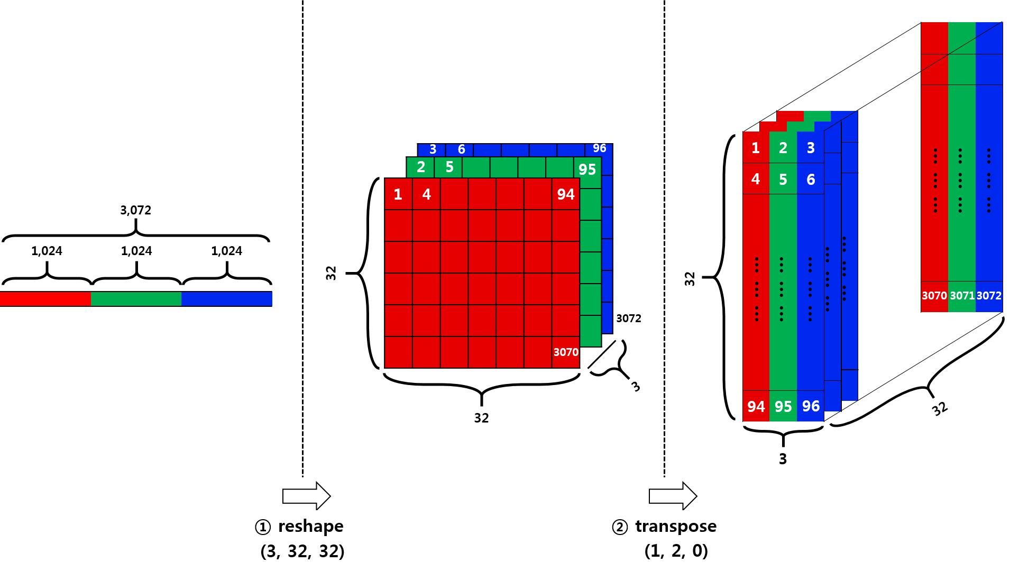

Fig 7. CIFAR 10 Image flattening - [Source](https://miro.medium.com/v2/resize:fit:2000/1*8mlH1a4MEOxr6wDjCZE8Ug.png)

**Curation of Labels:**

Parallel to the image restoration process is the task of handling the labels. Each image, as mentioned earlier, is paired with a specific label, denoting its category. Post the segregation process, these labels are carefully curated and archived within the `train_labels` list.

To encapsulate, this segment of the preprocessing regimen can be likened to an intricate dance where each move, whether it's segregation or reshaping, is performed with precision to ensure the data is primed for subsequent analytical endeavors

**4.1.5 Data Visualization**

Visualization provides a clear picture of the data. It's a way to turn numbers into easy-to-understand charts and images. For the CIFAR-10 dataset, visual tools can highlight how images are spread across classes and give a preview of the dataset's contents.

**Using Histograms and Box Plots:**

Histograms and box plots are great tools for checking the distribution of data. In this context, they were used to see how the various image classes are spread out in each batch. From the charts, it was observed that each batch has a nearly even distribution of classes. This means that no class is overly represented, which is good for training models.

pasted-image.tiff

Fig 8. Histograms of labels in each batch

pasted-image.tiff

Fig 9. Boxplots of labels in each batch

**Viewing Sample Images:**

To get a real feel for the dataset, some images from the training set were displayed. This not only gives a glimpse of what the images look like but also shows their diversity. Each image was labeled with its correct class name from the metadata, acting as a title. This helps in understanding what each image represents.

Fig 10. Sample Images from Dataset**pasted-image.tiff**

**Conclusion:**

The visualization steps offer valuable insights into the CIFAR-10 dataset. The even distribution of classes across batches ensures that there's no bias when training models. Displaying sample images gives a quick overview of the dataset, helping to set expectations for any further analysis or tasks.

**4.1.6 Data Transformation for Model Compatibility**

**Introduction:**

Before feeding the CIFAR-10 dataset into a machine learning model, it's crucial to ensure that the data aligns with the model's expectations. Different models require data in various formats. Thus, tailoring the dataset to the model's needs can lead to better results and smoother training processes.

**Converting Labels:**

One of the most essential steps in this phase is adapting the labels to be easily understood by the model. Here, labels get transformed into a categorical format using a utility function from TensorFlow. This conversion is particularly beneficial for models that generate probabilities for various classes. Instead of having a single label like "cat" or "dog", the model will now see and produce a probability score for each possible class.

**Aggregating Data:**

Once individual batches of images and labels have been prepared, they are combined to create a complete training dataset. This action results in a comprehensive dataset represented by `X` for images and `y` for labels. Now, instead of multiple smaller datasets, there's a single unified set that's ready to be fed into a model.

**Conclusion:**

Preparing the CIFAR-10 dataset by converting labels and aggregating data is fundamental. These steps ensure that the data is in the best shape for the model, allowing the training process to be efficient and effective. Properly preprocessed data lays the foundation for optimal model training and ultimately better predictions.

**4.2 Design and Architecture**

**Directory Setup for TensorBoard Logging:**

Before discussing the intricacies of model building, it's paramount to understand the preliminary steps that ensure efficient model monitoring and logging, especially when integrating with tools like TensorBoard.

The foundation is set with a systematic directory structure optimized for TensorBoard logging. This is vital as it ensures that each training or evaluation run is meticulously recorded, allowing for an in-depth comparison of various runs and configurations.

The principal directory denoted as ROOT_LOG_DIR is "logs". This acts as the central repository for all subsequent TensorBoard logging directories. Each unique training or evaluation session is assigned a distinct subdirectory within this main directory, based on the current date and time, ensuring precision in tracking. In the scenario where a specific subdirectory is desired, this can be provided through the subdir parameter, allowing for greater flexibility in organizing logs. The ultimate goal is a well-structured, timestamped directory system that streamlines the process of monitoring and comparing model performances.

**4.2.1 Model 1:**

In the realm of deep learning, the architecture of a model plays a pivotal role in determining its efficacy and performance on a given task. Model1 has been constructed with a meticulous blend of layers, each designed to serve specific purposes in the data processing pipeline:

Input Specifications:

The model starts with an initial layer designed to accommodate input images. These images are expected to be of a specific size, precisely 32 by 32 pixels, and must encompass three channels which are usually indicative of the RGB (Red, Green, Blue) spectrum in colored images.

**Convolutional Layers for Feature Extraction:**

Following the input layer, the model boasts an array of convolutional layers. Convolutional layers are instrumental in detecting patterns and features from images. They are adept at capturing spatial hierarchies of patterns using filters. The model incorporates four of such layers. The filters in these layers increase progressively: the initial layer employs 12 filters, the subsequent one uses 32, followed by 64, and culminating with 128 in the final convolutional layer. The kernel size for these filters is consistently set at 3 by 3 pixels, which strikes a balance between local and global feature extraction. The activation function for these layers is the Rectified Linear Unit (ReLU), a function favored for its simplicity and effectiveness in introducing non-linearity without demanding excessive computational power.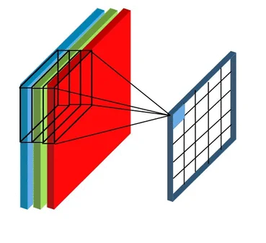

Fig 11. Convolution layer feature mapping - [Source](https://qph.cf2.quoracdn.net/main-qimg-b662a8fc3be57f76c708c171fcf29960)

**Transition to Linear Layers:**

Once the convolutional operations are complete, the data transitions from a multi-dimensional space to a flat, linear structure using the Flatten layer. This layer seamlessly reshapes the multi-dimensional output of the convolutional layers into a single long vector, paving the way for the dense, fully connected layers that follow.

**Dense Layers for Decision Making:**

The subsequent phase of the model is dominated by dense layers, often regarded as the decision-making chambers of neural networks. There are three dense layers in succession, with decreasing neuron counts: 256, 128, and 64 respectively. The ReLU activation is persistently employed in these layers as well. These layers essentially process the features extracted by the preceding convolutional layers and collectively contribute to the model's decision-making prowess.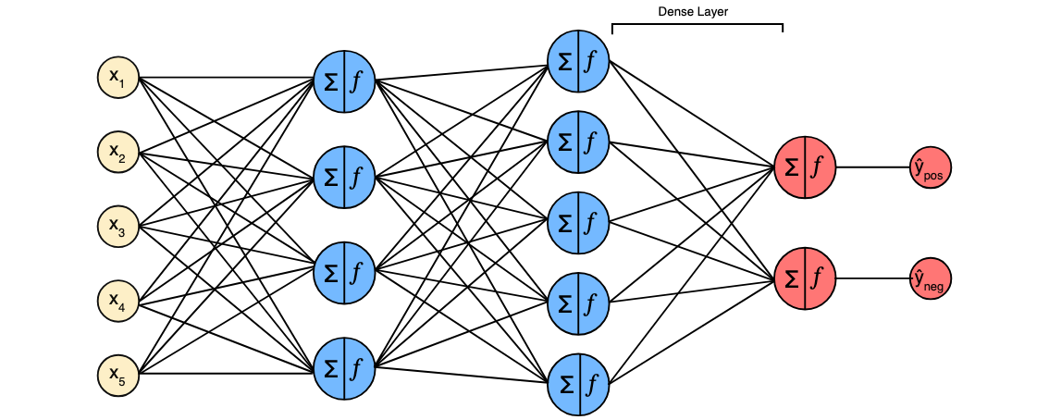

Fig 11. Dense Network - [Source](https://dkharazi.github.io/b42601b317eccd567828386074fccd5a/traxdense.svg)

**Output Layer:**

Culminating the architecture is the output layer, equipped with 10 neurons, mirroring the 10 possible classifications. The activation function employed here is the Softmax function. Softmax ensures that the output values are in the range of 0 and 1 and that they sum up to 1, making it ideal for multi-class classification tasks where the outputs are interpreted as class probabilities.

**4.2.2 Model 2:**

Model 2 leverages the architectural prowess of ResNet50, a renowned deep-learning model, and introduces additional layers tailored to the specific task at hand. The architecture and composition of Model2 are detailed below:

**Incorporation of ResNet50:**

At the very core of Model 2 lies the ResNet50 architecture. ResNet, which stands for Residual Network, is a deep convolutional neural network known for its depth and accuracy, especially when dealing with vast datasets like ImageNet. The "50" in ResNet50 denotes the presence of 50 layers, making it a deep network adept at handling intricate patterns in data.

ResNet's unique capability lies in its residual blocks which help in mitigating the vanishing gradient problem that's often encountered in deep networks. Introducing shortcuts or skip connections between layers, ensures that gradients can flow directly through the entire network.

For Model2, ResNet50 is employed in a slightly modified manner:

**1. Exclusion of Top Layers:** The `include_top` parameter is set to `False`. This implies that the fully connected layers at the top of the original ResNet50 model, generally responsible for ImageNet's 1000-class classification, are excluded. This allows customization of the model's ending layers to cater to specific tasks.

**2. Input Shape:** Given the task's requirements, the input shape is set to 32x32x3, accommodating images of 32 by 32 pixels with three color channels.

**3. Pooling Mechanism:** The pooling parameter is set to "avg", indicating the usage of average pooling. This technique condenses the feature maps outputted by the convolutional layers into a singular average value per feature, which can be particularly effective in reducing the model's computational demands without compromising the essence of the features.

**Tailored Output Layer:**

Subsequent to ResNet50's architecture, a dense layer with 10 neurons has been added. This layer serves as the decision-making entity for the task at hand. Each neuron corresponds to a potential classification category. The activation function employed is the Softmax function. Given its probabilistic nature, Softmax is a common choice for multi-class classification tasks. It ensures the output values lie between 0 and 1 and that their sum is equal to 1, facilitating the interpretation of these outputs as class probabilities.

In essence, Model2 combines the depth and feature extraction capabilities of ResNet50 with a custom-tailored output layer, aligning the architecture with the specific demands of the task.

**4.2.3 Model 3:**

Model 3 is characterized by its customized architecture that ingeniously incorporates convolutional blocks alongside dropout layers, followed by dense linear layers, culminating in an output layer tailored for a 10-class classification task. Here's a comprehensive breakdown of Model3's structure:

**Custom Convolutional Blocks - ConvBlock:**

Central to Model 3 is the custom-defined ConvBlock layer. This block is essentially a collection of consecutive layers, designed to carry out intricate feature extraction from the input data.

Within the ConvBlock, a sequence of operations is performed:

**1. Convolution (Conv2D):** This operation involves scanning the input with a filter (or kernel) to produce a feature map. It identifies patterns such as edges, textures, or more complex structures depending on the depth of the layer.

**2. ELU Activation Function:** Following the convolution operation, the ELU (Exponential Linear Unit) activation function is applied. ELU offers certain advantages over the commonly used ReLU, such as addressing the dying ReLU problem where certain neurons can sometimes get stuck during training and stop learning altogether.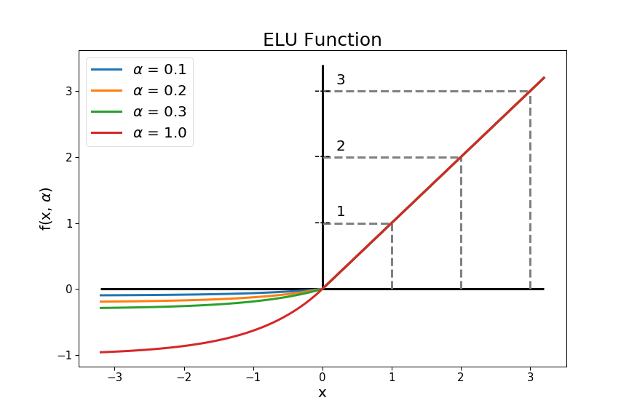

Fig 12. ELU Activation Function - [Source](https://tungmphung.com/wp-content/uploads/2020/02/elu_function.png)

**3. Batch Normalization:** This layer is integrated to stabilize and accelerate the training process. Normalizing the activations of the neurons in a given layer ensures that the distribution of activations does not shift too much, leading to faster convergence and potentially better generalization.

This sequence (Conv2D - ELU - BatchNormalization) is repeated twice within a single ConvBlock, reinforcing the depth of feature extraction.

**Sequential Construction of Model3:**

Having defined the ConvBlock, Model3's construction can be visualized as a series of these blocks, interspersed with dropout layers:

**1. Initial Input Layer:** Model 3 commences with an input layer shaped to handle images of 32x32 pixels with three color channels.

**2. ConvBlocks and Dropout Layers:** Three ConvBlocks are successively stacked, each increasing in the number of filters: 32, 64, and 128. After every ConvBlock, a Dropout layer is added. Dropout acts as a regularization technique by randomly setting a fraction of input units to 0 at each update during training, preventing overfitting. The rate of dropout increases progressively from 0.3 to 0.5, indicating a more aggressive dropout as the network delves deeper.

**3. Linear Layers:** Post the convolutional operations, the data is flattened into a 1D array, leading to a series of dense (or fully connected) layers. These layers further transform the features, making them more suited for the final classification task. The depth of these layers is evident from the descending number of neurons: 1024, 256, 128, and 64.

**4. Output Layer:** The architecture culminates in an output layer with 10 neurons, employing the Softmax activation function. This final layer is responsible for delivering class probabilities for the 10 potential categories.

In summary, Model 3 is a testament to the versatility of deep learning. By intertwining custom convolutional blocks, dropout layers for regularization, and dense layers for fine-tuning, Model 3 stands poised for effective multi-class image classification.

**4.2.4 Model 4:**

Model4 is a refined neural network that integrates custom convolutional blocks, dropout regularization, and dense layers for feature transformation, ultimately leading to multi-class classification. The structure and nuances of this model are detailed as follows:

**Custom Convolutional Blocks - ConvBlock:**

A highlight of Model 4 is the custom-defined ConvBlock layer. Designed for intricate feature extraction, the block is a collection of multiple consecutive layers.

Within each ConvBlock, the following operations ensure:

**1. Convolution (Conv2D):** It scans the input using a filter to yield a feature map. This operation discerns patterns such as edges or more complex hierarchical features based on the depth within the network.

**2. ReLU Activation Function:** After the convolution, the ReLU (Rectified Linear Unit) activation function is applied. This function introduces non-linearity into the model, enabling it to learn and approximate more complex functions.

**3. Batch Normalization:** Incorporated to regulate and hasten the training process. By normalizing neuron activations, assures that the distribution remains consistent, fostering faster convergence.

This sequence of Conv2D, ReLU, and BatchNormalization is reiterated within a single ConvBlock, fortifying the depth of feature discernment.

**Sequential Assembly of Model4:**

The ConvBlock's essence is reflected in Model4's design, which is elucidated as a sequence of these blocks coupled with dropout layers:

**1. Initiating Input Layer:** The model begins with an input layer primed for 32x32 pixel images with three color channels.

**2. ConvBlocks with Dropout Layers:** Model 4 is constructed with a series of three ConvBlocks, each amplifying in filter numbers: 32, 64, and 128. Interspersed between these blocks are Dropout layers, serving as a regularization mechanism. By setting a random subset of neurons to zero during training, Dropout averts overfitting. The increasing dropout rate, from 0.3 to 0.5, suggests a stringent regularization as the depth intensifies.

**3. Linear Layers:** Following the convolutional segment, the data is morphed into a one-dimensional array, ushering into a chain of dense layers. These layers undergo further feature transformations, fine-tuning them for the impending classification. The layer sizes sequentially taper from 1024 neurons to 256, then 128, and finally 64.

**4. Terminal Output Layer:** Model 4 culminates with an output layer bearing 10 neurons and utilizing the Softmax activation function. This definitive layer dispenses class probabilities for the envisioned 10 classes.

To encapsulate, Model4 melds the potency of custom convolutional blocks with the robustness of dropout layers and the specificity of dense layers, making it a formidable contender for adept multi-class image categorization.

**4.3 Model Compilation**

For a neural network to translate its structure into actionable insights, it requires precise instructions on how to learn from data. These directives are rendered during the model compilation phase. Here’s a detailed breakdown of the parameters used:

**4.3.1 Loss Function:**

In the context of training neural networks, the loss function plays a pivotal role. It essentially provides a measure of how well the model's predictions align with the actual outcomes, thus providing a means to adjust the model during training. For classification problems, especially when dealing with multiple classes, the Categorical Cross entropy loss is a popular choice. Let's dive deeper into its attributes:

**1. Nature of the Problem:**

**- Classification Task:** In machine learning, classification involves predicting the category or class of a given input. When there are more than two classes involved, it's termed as a multi-class classification problem.

**- Probabilistic Output:** Neural networks for classification tasks typically output a probability distribution over classes, indicating the likelihood of the input belonging to each class.

**2. Categorical Crossentropy Explained:**

**- Essence:** Categorical Crossentropy quantifies the difference between two probability distributions: the predictions made by the model and the actual distribution of the labels.

**- Formula:** Mathematically, it is the negative sum of the product of the actual class labels and the logarithm of the predicted probabilities.

**- Intuition:** If the model's prediction is perfect (i.e., it assigns a probability of 1 to the correct class and 0 to others), the loss is zero. Conversely, if the model's prediction is entirely wrong, the loss tends towards infinity.

**3. Importance in Training:**

**- Guiding the Model:** During training, the objective is to minimize the value of the loss function. The gradients derived from this loss guide the optimizer in adjusting the model's weights.

**- Reflecting Model Confidence:** Not only does the Categorical Crossentropy loss consider whether the prediction is correct or not, but it also takes into account how confident the model was in its prediction. A prediction made with high confidence but is wrong will be penalized more heavily.

**4. Benefits:**

**- Robustness:** The nature of the Categorical Crossentropy ensures that it is robust against slight changes, making it reliable for a wide range of classification problems.

**- Clear Feedback:** It provides a clear and quantitative measure of the model's performance, which can be instrumental when fine-tuning and optimizing.

**- Encourages Confident Predictions:** By penalizing wrong predictions more when made with high confidence, it nudges the model to be more cautious in its predictions.

In summary, the Categorical Crossentropy loss function is an integral part of training multi-class classification models. It offers a robust and clear measure of the model's prediction accuracy and confidence, directing the optimizer efficiently during the training process to enhance the model's overall performance.

**4.3.2 Optimizer - Adam:**

The optimization algorithm plays a pivotal role in the learning process of a neural network. Its primary function is to adjust the model's weights based on the computed gradients to minimize the loss. Among various optimization techniques available, the Adam optimizer has gained significant attention and is extensively employed in deep learning tasks. Let's delve deeper into its attributes:

**1. Background and Origin:**

**- Name Origin:** "Adam" stands for Adaptive Moment Estimation. It's a nomenclature derived from its methodology of computing adaptive learning rates for each parameter.

**- Combination of Techniques:** Adam ingeniously combines the strengths of two other optimization techniques: AdaGrad (Adaptive Gradient Algorithm) and RMSprop (Root Mean Square Propagation).

**2. Core Characteristics:**

**- Moment Estimation:** Adam maintains an exponentially decaying average of past gradients, akin to momentum. This characteristic assists in navigating ravines, a common issue where gradients can be steep in one dimension and shallow in another, thus speeding up convergence.

**- Adaptive Learning Rates:** By calculating moment estimates over time, Adam dynamically adjusts the learning rates for each parameter. This adaptiveness is especially beneficial when dealing with sparse data or parameters that don't need significant updates.

**3. Learning Rate Parameter:**

**- Significance:** The learning rate is one of the most critical hyperparameters for any optimization algorithm. It determines the magnitude of updates made to model weights after computing the gradient from the loss function.

**- Choice of Value:** A smaller learning rate, like 1e-4 in our models, implies that the model will take small, incremental steps towards finding the optimal weights. While this cautious approach ensures we don't skip over optimal solutions, it might also imply that the model may require more iterations or epochs to converge fully. It's a delicate balance between the speed of convergence and the accuracy of the final solution.

**4. Benefits:**

**-Efficient Convergence:** Owing to its adaptive nature, Adam often ensures a quicker convergence compared to other optimizers.

**- Memory Efficiency:** Adam doesn't require a significant memory overhead, making it suitable for models with numerous parameters.

**- Robustness:** Adam displays resilience against minor changes in hyperparameters, which aids in simplifying the model tuning process.

In essence, the Adam optimizer, with its adaptiveness and combination of best optimization techniques, equips our models to navigate the complex optimization landscape effectively, leading them closer to the most suitable weights that define their performance.

**3. Metrics:**

Metrics are crucial in the machine learning domain as they provide an understanding of the model's performance. While the loss function is essential for training a model, metrics are mainly used for evaluation. Among various metrics, "accuracy" is one of the most straightforward and commonly employed in classification tasks. Let's explore its nuances:

**1. Definition:**

**Accuracy:** It is the ratio of correctly predicted instances to the total instances in the dataset. Simply put, it measures the fraction of predictions that the model got right.

**2. Calculating Accuracy:**

**- Formula:** Accuracy = (Number of Correct Predictions) / (Total Number of Predictions).

**- Scope:** It takes values between 0 and 1 (or 0% and 100%), where 1 (or 100%) indicates that every prediction was correct, and 0 (or 0%) indicates none of the predictions were correct.

**3. Utility in Evaluation:**

**- Performance Gauge:** Accuracy serves as a quick check on the model's effectiveness, especially when the class distribution is balanced.

**- Interpretability:** Given its straightforward nature, it's easily interpretable even for individuals without a deep background in machine learning.

**4. Points of Consideration:**

**- Imbalanced Data:** In scenarios where the classes are imbalanced, accuracy might not be the best metric. For instance, if 95% of the data belongs to class A and only 5% to class B, a naive model predicting every instance as class A will still achieve 95% accuracy.

**- Alternative Metrics:** In cases where class imbalances are prevalent, or where false positives and false negatives have different costs, other metrics such as precision, recall, F1-score, or the area under the ROC curve might be more appropriate.

**5. Importance in the Context:**

**- Feedback Loop:** Even though the model is trained using the loss function, accuracy provides a more intuitive sense of performance, making it easier to communicate results and improvements.

**- Benchmarking:** Accuracy serves as a standard metric allowing comparisons between different models or between versions of the same model over time.

To conclude, accuracy is a fundamental metric in classification problems, offering an easily understandable insight into the model's performance. While it's invaluable in many contexts, it's equally important to be aware of its limitations, especially in scenarios with imbalanced datasets or different costs associated with different types of errors. In such cases, a combination of metrics might be more informative.

Overall, the compilation phase is cardinal in setting the training course for the models. Through the chosen optimizer, loss function, and metrics, the models are equipped to learn effectively, optimize their weights, and offer a coherent measure of their performance.

**4.4 Model Training**

**4.4.1 Setting Callbacks**

In the realm of deep learning, callbacks are instrumental, acting as utilities that are invoked at specific stages during the training of a model. They afford a higher degree of control over the training process, allowing for specific actions to be undertaken based on the training state or model's performance. Here's an in-depth elucidation of the callbacks employed:

**1. Model Checkpoint:**

**Purpose:**

The primary role of this callback is to safeguard the progress made during model training. Routinely saving the model's weights throughout the training procedure, ensures that one does not lose significant progress due to unforeseen interruptions or computational issues.

**Key Features:**

**- Monitoring Metrics:** This function watches a particular metric, often the validation loss, to determine the optimal point for saving the model. Essentially, it ensures that the saved model or weights represent the state with the best-observed performance on the validation set.

**- Weights-only Saving:** Instead of saving the entire model architecture, only the weights are stored. This is particularly beneficial in terms of storage efficiency.

**Benefits:**

**- Protection Against Data Loss:** It acts as insurance against potential system crashes or interruptions, ensuring that one can resume from the last saved state.

**- Efficient Model Retrieval:** By monitoring specific metrics, it guarantees that one can always retrieve the model state that has shown the most promise during training.

**2. Early Stopping:**

**Purpose:**

To enhance computational efficiency and to combat the risk of overfitting, the early stopping callback is crucial. It monitors the model's performance and halts the training process if there hasn't been any improvement for a stipulated number of epochs.

**Key Features:**

**- Metric Monitoring:** This function consistently keeps an eye on a designated metric, such as the validation loss, to assess the model's performance.

**- Patience:** The number of epochs with no improvement after which training will be stopped. By specifying this, one ensures that abrupt fluctuations in performance don't prematurely end the training. Instead, a consistent lack of improvement signals the cessation of the process.

**Benefits:**

**- Prevention of Overfitting:** By halting training once the performance plateaus, it ensures the model doesn't start memorizing the training data, which could lead to poor generalization on unseen data.

**- Resource Efficiency:** It ensures computational resources aren't wasted on training that isn't yielding better results.

**3. TensorBoard Logging:**

**Purpose:**

Visualization is a potent tool when understanding and interpreting model training. This callback logs essential training metrics, allowing them to be visualized using TensorBoard.

**Key Features:**

- **Directory Logging:** Metrics and other relevant data are logged in specific directories, typically named based on the model or the time of training initiation. This structured logging facilitates easier navigation and comparisons between different training sessions.

**Benefits:**

**- Insightful Visualizations:** TensorBoard provides graphical representations of metrics like loss and accuracy, making it easier to interpret and analyze the training progress.

**- Comparison:** Different training sessions can be juxtaposed, aiding in the identification of optimal model configurations and training parameters.

**4.4.2 Training Procedure and Visualization**

In the realm of deep learning, training a model is of paramount importance. It is during this crucial phase that a model assimilates the intricacies of the data, striving to understand underlying patterns and relationships. Delving deeper into the training phase reveals several nuanced facets.

**1. Model Fitting:**

The process of 'fitting' signifies the model's journey of self-improvement. As the model is exposed to data, it constantly evaluates its predictions against the actual outcomes. Through iterative processes, the model's internal parameters (commonly known as weights) undergo adjustments. These adjustments aim to minimize the difference between the model's predictions and the actual values, ultimately enhancing the model's accuracy.

**2. Utilizing Batches:**

Given the often voluminous nature of datasets in deep learning, processing all data simultaneously can be computationally challenging. To address this, data is often divided into smaller subsets, termed 'batches'. In our context, each batch comprises 128 data points. The model processes these batches sequentially, updating their weights after each batch, making the training more manageable and efficient.

**3. Defining Epochs:**

An 'epoch' denotes a singular cycle where the model has been exposed to every data point in the dataset once. Determining the number of epochs is a balancing act. While more epochs offer the model more opportunities to learn, it also runs the risk of overfitting, where the model becomes exceedingly attuned to the training data, compromising its performance on unseen data. In our scenario, the model undergoes training for 20 epochs, striking a balance between learning and the risk of overfitting.

**4. Validation Data:**

To assess the model's performance on unseen data and prevent overfitting, a portion of the training data is set aside as 'validation data'. This subset, which accounts for 20% of the total data in our case, is not used directly for training. Instead, after each epoch, the model's performance is gauged on this validation data. This offers insights into how well the model might perform in real-world scenarios.

**5. Implementing Callbacks:**

As the training progresses, it's beneficial to have mechanisms that monitor the model's performance and make intelligent decisions. 'Callbacks' serve this very purpose. They are essentially routines that are executed at specific stages of the training process. For instance, a mechanism saves the model's weights at points where its performance on the validation data is optimal. Another might halt the training if the model's performance plateaus or deteriorates, ensuring efficiency.

**6. Loading the Best Weights:**

After the culmination of the training process, it's imperative to ensure that the model is in its most optimal state. By loading the weights that showcased the best performance on the validation data, one can be confident that the model is well-poised to make accurate predictions on new, unseen data.

**4.5 Model Evaluation**

4.5.1 Training and Validation Curves

In the domain of deep learning, training a model is just one part of the equation. Once the model has been trained, it becomes essential to rigorously evaluate its performance. This evaluation not only reveals how well the model has learned but also predicts its capability to handle new, unseen data. In our deep learning journey, we employ a multifaceted approach to model evaluation. Here's a deeper dive into the evaluation techniques:

**1. Training Curves:**

A commonly adopted and highly informative method of evaluation is the use of training curves. These graphical representations chart the model's performance metrics across different stages of the training process.

**Loss Curves:** The loss curve illustrates the model's error rate during its training. By plotting the loss values for both training and validation datasets, we can comprehend the model's progression. A decreasing loss indicates that the model is learning, while a widening gap between the training and validation loss can signify overfitting.

**Accuracy Curves:** Complementing the loss curves, the accuracy curves depict how accurately the model is making predictions. By observing the accuracy values for both training and validation datasets, one can gauge the model's efficiency and robustness. A high accuracy on the training dataset and a comparably lower one on the validation dataset could highlight overfitting.

**2. Leveraging TensorBoard:**

TensorBoard, a magnificent visualization tool, takes model evaluation to another level. It provides real-time insights and visualizations, enabling a comprehensive understanding of the model's performance. Here are the aspects we observe through TensorBoard:

**Accuracy and Loss Metrics:** Through intuitive graphs, TensorBoard displays the model's accuracy and loss over iterations, enabling an at-a-glance understanding of how well the model is fairing during its training journey.

**Evaluation Accuracy vs. Iterations:** This visualization provides a clear picture of how the model's accuracy on the evaluation dataset evolves with each iteration. It's instrumental in assessing the model's learning rate and potential plateaus.

**Evaluation Loss vs. Iterations:** Mirroring the accuracy, this graph sheds light on the model's error rate on the evaluation dataset across iterations. Observing this can help in pinpointing issues like underfitting or overfitting.

In summation, model evaluation is an intricate and crucial process. By harnessing the power of training curves and the advanced capabilities of TensorBoard, we can not only assess the model's current performance but also make informed decisions on potential improvements or modifications.

4.5.2 Testing the Model

After the meticulous process of model training and evaluation on the training and validation datasets, it's time to put our model to the ultimate test - evaluating it on a completely unseen dataset. This phase is essential as it provides insights into the model's real-world applicability and performance.

For our deep learning models, we utilize a test dataset comprising 10,000 images. This dataset is particularly distinct from the data that the model has encountered during the training phase. Thus, it serves as an excellent yardstick for gauging the model's true predictive prowess.

Here's a breakdown of the testing process:

**1. Preparing the Test Dataset:**

Before we can evaluate our model, the test dataset needs to undergo the same preprocessing steps as the training dataset. This ensures consistency and enables the model to make accurate predictions.

**2. Running the Model:**

With the test dataset ready, the model is exposed to these 10,000 images. It proceeds to make predictions based on what it has learned during the training phase.

**3. Analyzing Predictions:**

Once the model has made predictions, it's crucial to compare these against the actual labels of the test dataset. This comparison allows us to understand how often the model is correct and where it might be going wrong.

**4. Metric Calculation:**

By contrasting the predicted labels against the actual ones, we can compute various metrics such as accuracy, precision, recall, and F1-score. These metrics provide a comprehensive understanding of the model's strengths and areas that might require further refinement.

**5. Drawing Conclusions:**

Based on the model's performance on the test dataset, decisions can be made. If the model showcases commendable accuracy, it might be ready for deployment in real-world applications. However, if there are discrepancies, it indicates the need for model fine-tuning or reconsideration of the training approach.

In conclusion, testing on an unseen dataset is a pivotal step in the model development cycle. The results from this phase offer a genuine representation of the model's capabilities and readiness for real-world challenges. Utilizing a significant set of 10,000 images ensures that our assessment is thorough and rooted in a strong foundation.

**5. Analysis and Results**

**5.1 Model Accuracy and Loss**

In deep learning, the effectiveness of a model is often measured by its accuracy and the loss it exhibits throughout the training process. These indicators, charted over successive training cycles known as epochs, provide insight into the model's proficiency at assimilating the training data and its capacity to apply this learning to a validation set that it has not previously encountered.

**Model 1 Training Curves Analysis:**

**Loss Curve Analysis:**

The decline in the training loss shown by the blue line is a good sign that Model 1 is learning well from the training data, with the loss reaching as low as 0.1235. But when we look at how the model does with new data—the validation data—the orange line shows us that after the loss decreases, it doesn't get much better after a certain point, ending up at 1.7857. This could mean the model is not as good at making predictions on data it hasn't been trained on.

**Accuracy Curve Analysis:**

The model's training accuracy, represented by the blue line, goes up to 0.9705, which tells us that the model can correctly identify most of what it was trained on. However, the model's validation accuracy, shown by the orange line, is not as high, stopping at 0.5830. This big difference between how well the model does with training data and new data suggests that the model might be too focused on the training data and not able to apply what it learned to new situations.

These observations from Model 1's training curves tell us that even though the model is very accurate with the data it was trained on, we can't be sure it will do as well with new data. The model seems to be struggling to apply its learning more broadly, which means we might need to use techniques like adding more variety to the training data or using different methods to prevent overfitting to help the model learn in a way that's more useful for making predictions on data it hasn't seen before.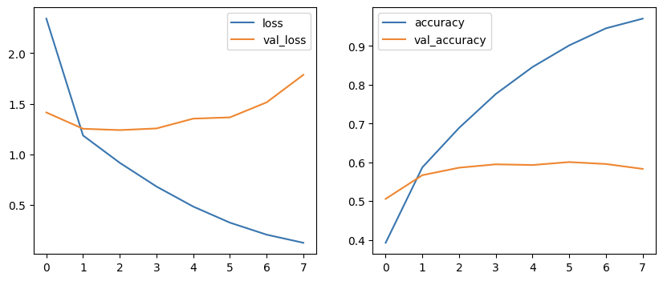

Fig 13. Model 1 Training Curves

**Model 2 Training Curves Analysis:**

**Loss Curve Analysis:**

The training loss for Model 2, shown by the blue line, consistently goes down, which is a good sign that the model is learning from the training data. The fact that the training loss reaches as low as 0.0852 indicates the model is making fewer mistakes as it learns. However, when we look at the validation loss, shown in orange, we see it falls initially but then stops improving, ending at 0.9786. This could mean that the model isn't getting better at predicting new data it hasn't seen before.

**Accuracy Curve Analysis:**

Looking at the model's accuracy, the blue line increases to a high level of 0.9730 on the training set, which tells us the model is correctly identifying most of the training images. On the other hand, the validation accuracy, shown in orange, also goes up but not as high, ending at 0.7595. The noticeable difference between the training and validation accuracy could indicate that the model might be too focused on the training data and not as good at handling data it wasn't trained on.

The information from Model 2's training suggests that while the model does a good job with the data it's been trained on, it may need some adjustments to do better with new data. The results show there's a need for additional steps, like using more varied data or changing the model slightly, to help the model learn better and make more accurate predictions on data it hasn't seen before.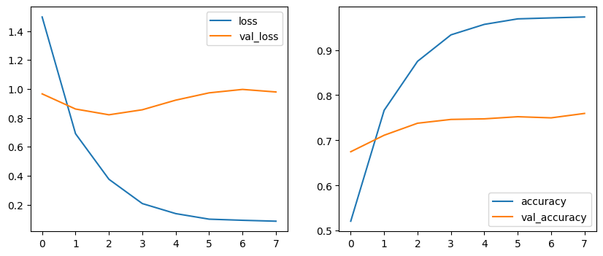

Fig 14. Model 2 Training Curves

**Model 3 Training Curves:**

**Loss Curve Analysis:**

The blue line illustrating Model 3's training loss shows a clear downward trend, which means the model is getting better at handling the training data, with the loss reducing to 0.4122. The validation loss, marked by the orange line, also goes down, yet it experiences some ups and downs. This ends at 0.9661 and indicates that while the model is learning from the training data, its ability to deal with new, unseen data might not be as strong due to the fluctuations in performance.

**Accuracy Curve Analysis:**

The training accuracy for Model 3, depicted by the blue curve, shows steady progress, which is a good sign that the model is improving how it predicts the training data, achieving an accuracy of 0.8543. The validation accuracy, indicated by the orange curve, also increases over time and reaches 0.7192. This upward movement is promising and suggests that the model has a decent ability to generalize what it has learned to new data. However, the gap between the training and validation accuracy points to the fact that the model still performs better on data it has seen during training than on new data.

From the training and validation curves for Model 3, we can conclude that the model is learning and improving its predictions on the training data. However, the minor fluctuations in validation loss and the accuracy gap highlight that there might be room for the model to better understand the complexities of unseen data. This could involve revisiting the model's architecture or tuning the hyperparameters to achieve a balance that would allow for better performance on both the training and unseen data.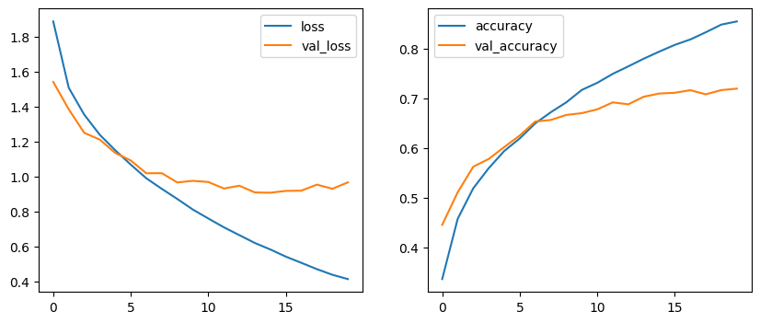

Fig 15. Model 3 Training Curves

**Model 4 Training Curves:**

**Loss Curve Analysis:**

Looking at the loss trends, Model 4's blue curve tells us that the model is getting better and better at understanding the training data, with training loss dropping to a very respectable 0.3490. The validation loss, shown in orange, decreases as well and levels off a bit at the end, finishing at 1.0557. This slight leveling suggests that with a few tweaks, the model could be well-optimized for both the training and new, unseen data.

**Accuracy Curve Analysis:**

The training accuracy for Model 4 increases steadily, as the blue line shows, which means the model is becoming quite reliable in identifying what it has learned, achieving a high accuracy of 0.8752. For the validation accuracy, which ends at 0.7110, the orange line also rises consistently. This upward trend in validation accuracy is particularly promising as it suggests the model isn't just memorizing the training data but is also effectively applying what it has learned to new data. The gap between the training and validation accuracy, while present, is smaller compared to the other models, indicating a better balance between learning from the training data and generalizing to validation data.

Model 4 stands out as the best-performing model among all four, showing not only a strong learning capability from the training data but also a good degree of transferability of that learning to new scenarios. The trends suggest that Model 4, with its solid foundation and balanced performance, holds excellent potential for further tuning and real-world application.



Fig 16. Model 4 Training Curves

**5.2 Error Analysis**

From the training curves presented for the four models, we can draw several inferences related to potential errors:

**Overfitting:** Models often manifest overfitting when the training accuracy soars significantly higher than validation accuracy. For instance, in Models 1 and 2, the discernible gap between training and validation accuracies towards the latter epochs suggests that the model might be too closely fitting to the training data, possibly missing out on general trends.

**Plateauing Validation Loss:** A validation loss that stabilizes or even rises while the training loss continues to drop is a clear indicator of the model struggling to generalize its learning to unseen data. In the context of Models 3 and 4, while the validation loss does showcase a decline, the minor fluctuations and eventual plateau can be a point of concern.

**Learning Speed:** The pace at which the loss drops or accuracy rises also provides insights. A too-rapid rise in accuracy or drop in loss might suggest that the model is memorizing the training set rather than learning generalized patterns. On the other hand, a very gradual change could indicate underfitting or that the model architecture might be too simplistic for the given data.

**Recommendations:** A finer-grained error analysis could involve inspecting misclassified instances, analyzing if certain categories or types of data consistently pose challenges. Techniques such as data augmentation, regularization, or even a review of the data preprocessing stages might help address these concerns.

**5.3 Comparing with Other Models**

**Consistency Across Epochs:** While all models showcase an improving trend, Models 3 and 4 exhibit a more consistent growth in both accuracy and loss reduction over extended epochs. Such models, with consistent performances, often have better stability and reliability in practical applications when compared to other architectures that might converge faster but with more volatility.

**Gap Between Training and Validation:** Ideally, in state-of-the-art models, the gap between training and validation metrics is minimal. Models 1 and 2, with a widening gap as epochs progress, might not be as robust as other architectures that maintain a closer parity between training and validation curves.

**Handling of Complex Data:** The gradual fluctuations in the validation loss for Models 3 and 4, especially in the middle epochs, might suggest that alternative models or techniques that handle such data variations more smoothly could be considered superior.

**Recommendations:** While our models provide valuable insights and perform commendably, a more exhaustive comparison against other leading architectures in the field would provide a clearer benchmark. Factors like computational efficiency, adaptability to different data types, and ease of integration into applications should also be considered when comparing with other models.

**5.4 Conclusion**

Among the four models assessed, Model 4 stands out as the superior choice due to its consistent performance and strong generalization on validation data. The training and validation curves for Model 4 display a steady progression of learning, with a notable improvement in handling new data. The model maintains a modest yet stable increase in validation accuracy, indicative of its robust ability to adapt to unfamiliar data without significant overfitting, a challenge commonly observed in the other models. This consistent improvement in validation accuracy underscores Model 4's potential as a versatile and reliable model for practical applications, where it's essential for models to not only learn from their training data but also to apply this learning effectively to new situations.

Moreover, the slight leveling off in Model 4's validation loss suggests there is room for further optimization, which could lead to even better performance with fine-tuning. The smaller gap between its training and validation accuracy, compared to the other models, reflects a balanced approach to learning that values both precision and adaptability. In essence, Model 4's solid and steady learning curve signals a readiness for real-world tasks, marking it as the most promising among the models evaluated, with ample opportunity for future enhancements and application in diverse scenarios.

**Deployment**

Telegram is a popular messaging app known for its focus on speed and security, widely used for both personal and professional communication. In the context of our project, we have taken the innovative step of deploying Model 4 within Telegram as a bot, a software application that runs automated tasks. This deployment method transforms Model 4 from a static machine learning model into an interactive service that users can engage with directly within the Telegram platform.

The advantage of deploying Model 4 as a Telegram bot lies in its accessibility and ease of use. Users can interact with the bot by simply sending images to it, just as they would message a friend. Within moments, the bot utilizes Model 4 to analyze the image and returns a prediction of its content. This real-time interaction not only provides immediate value to the user but also presents a novel way to experience and benefit from machine learning technology without requiring specialized knowledge or additional software.

The benefits of deploying on Telegram are manifold. Firstly, it allows for widespread adoption, given Telegram's large user base. Users can effortlessly access advanced image classification technology from their mobile devices or computers, making it incredibly user-friendly. Secondly, it offers the potential for continuous improvement of the model. With each interaction, Model 4 receives diverse data from users around the world, which can be used to further refine and enhance its predictive accuracy. Lastly, it encourages user engagement and provides a platform for feedback, which is invaluable for iterative development and maintaining the model's relevance to real-world needs and scenarios.

In summary, deploying Model 4 as a Telegram bot offers a direct and simplified channel for users to benefit from machine learning advancements. It not only democratizes access to complex technology but also fosters an environment for continuous learning and development of the model.





Sample usage and responses from the bot

**Conclusion**

Over the course of this project, we embarked on an explorative journey into the realm of deep learning, employing diverse model architectures to address the challenges presented by our dataset. The various training curves provided a window into the performance and potential pitfalls of each model, guiding us towards iterative improvements and refinements.

The nuanced differences in the performance metrics across the models highlighted the intricacies and unpredictabilities of neural networks. While some models demonstrated rapid convergence, others showcased a more steady, albeit slower, trajectory towards optimization. The disparities between training and validation metrics in certain models illuminated the ever-present specter of overfitting, underscoring the importance of robust regularization techniques and data augmentation.

Comparing our models with other established architectures offered valuable insights into the current state-of-the-art in the domain. While our models held their ground commendably, the exercise emphasized the importance of continuous learning and adaptation in this rapidly evolving field.

In conclusion, this project was not just about training models and analyzing metrics but was an enlightening experience in understanding the art and science behind deep learning. The challenges faced, lessons learned, and the knowledge acquired have laid a solid foundation for future endeavors in this domain. We are optimistic about the potential applications and improvements that the future holds, armed with the insights gleaned from this endeavor.

**References**

* Dataset. CIFAR-10 and CIFAR-100 datasets. (n.d.). <https://www.cs.toronto.edu/~kriz/cifar.html>
* Divya, S., Adepu, B., & Kamakshi, P. (2022). Image Enhancement and Classification of CIFAR-10 Using Convolutional Neural Networks. In 2022 4th International Conference on Smart Systems and Inventive Technology (ICSSIT). 2022 4th International Conference on Smart Systems and Inventive Technology (ICSSIT). IEEE. <https://doi.org/10.1109/icssit53264.2022.9716555>
* Pandit, S., & Kumar, S. (2020). Improvement in Convolutional Neural Network for CIFAR-10 Dataset Image Classification. In International Journal of Computer Applications (Vol. 176, Issue 37, pp. 25–29). Foundation of Computer Science. <https://doi.org/10.5120/ijca2020920489>
* Lv, X. (2020). CIFAR-10 Image Classification Based on Convolutional Neural Network. In Frontiers in Signal Processing (Vol. 4, Issue 4). Isaac Scientific Publishing Co., Ltd. <https://doi.org/10.22606/fsp.2020.44004>
* Doon, R., Kumar Rawat, T., & Gautam, S. (2018). Cifar-10 Classification using Deep Convolutional Neural Network. In 2018 IEEE Punecon. 2018 IEEE Punecon. IEEE. <https://doi.org/10.1109/punecon.2018.8745428>